Developer Guide
jWebSocket
Python client library

Author?

Version History?

Overview
The project's main objective is to increase the usability of the jWebSocket framework. To achieve this we implemented a client library that allows developers of the Python programming language to develop applications using jWebSocket as an application server. They claim to create a library light but it meets all the expectations of developers. Whow! Big assumption! What are “all the expectations” ? If you say so, I would like to read some examples,otherwise defuse a bit ;-)
- Infrastructure, Model, Approach
In general the solution has been designed to support two core layers providing two ways of use for the client. Layers is divided into a high and a low level which meet the specifications of WebSockets in general and the jWebsocket server in particular.
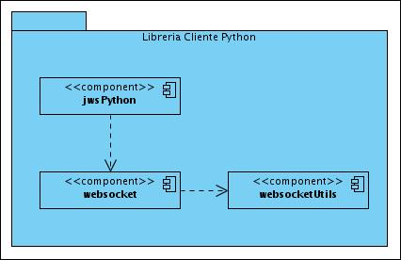
Figure 1: Diagram of components of the Python client library for jWebSocket.

In the diagram you see the two fundamental layers used to model the library. The component is named jwsPython high-level layer which functions as an abstraction for the WebSocket protocol following features and functionalities jWebsocket server. WebSocket component represents a low-level implementation specification of the W3C and the IETF for the WebSocket protocol in the Python programming language, using this component you can communicate with any server that meets the WebSocket protocol standards . The component websocketUtils contains a set of classes and algorithms used to implement the protocol.
One of the design patterns used is the Observer pattern which allows subscribing to events related to connecting and sharing information.
Although the library is designed for use in client-server applications this solution only implements all parts concerning the client-side code. Bone is not implemented anything jWebSocket server to accept requests from the client Python if you deploy a client library used the Python programming language that meets the specifications proposed by the jWebsocket server. (I don’t understand this sentence, please compare that be with your Spanish version and review the English version accordingly).

Requierement and prerequisites
The prerequisites of this library are practically null, as it only requires installation of Python on your computer. Please give a short sentence where and how to get that and a link how to install.

Modules, Structures
All files that make up the library are located in the folder websocket_client as shown in the image below:
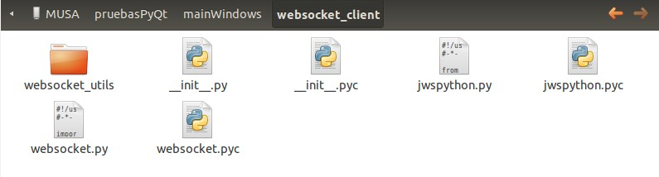
Figure 2: Root Folder.
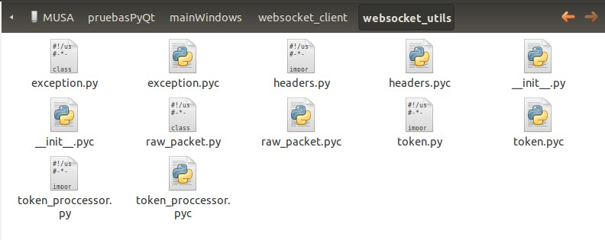
As shown in the image above into the root directory the high-level and low level components of the library are located that can be used by the developers.
Figure3: websocket_utils.
Websocket_utils directory shown below are several classes and algorithms that are useful for the library in general. The following gives a brief explanation of the elements included in the module websocket_utils.
- Exeption: Custom exceptions defined for the library.
- Headers: Methods are defined with the algorithms necessary to convert an object of type WebsocketRawPacket a logical sequence of bytes to be sent as specified by the protocol outlined in the picture below.
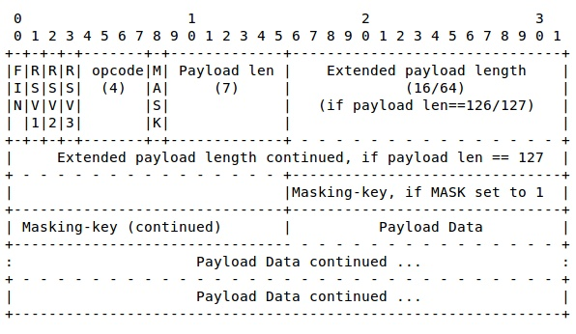

- WebsocketRawPacket: An object that contains the data and the specifications needed to build the package that meets the standard defined in the WebSocket protocol.
- Token: Object used as subprotocol form of communication or understanding with jWebSocket server. A token is only an object that has a namespace and a type of token as well as additional information from the application itself.
- token_proccessor: Contains the algorithms necessary to convert the token to JSON format to be sent when and to convert native Python objects once they are received.

Source Code

Component: websocket
class | WebSocket
Description | This class acts as a client that implements low-level native WebSocket protocol specifications.
Dependence | import uuid  import socket  import thread  import base64  import hashlib  import logging  from urlparse import urlparse  from websocket_utils import headers  from websocket_utils.exception import WebSocketException, ConnectionClosedException  from websocket_utils.raw_packet import WebsocketRawPacket
Properties | List of member variable of the class.
connected | Boolean: True or false depending on connection status.
on_text_message | Function: Reference to the callback function used as a listener when you receive a text message.
on_binary_message | Function: Reference to the callback function used as a listener when a message is received binary.
on_open | Function: Reference to the callback function used as a listener when you open the connection.
on_close | Function: Reference to the callback function used as a listener when you close the connection.
on_ping | Function: Reference to the callback function used as a listener when it receives a ping from the server.
on_pong | Function: Reference to the callback function used as a listener when receiving a pong from the server.
io_sock | Socket: Native TCP socket of the Python programming language during the connection to the server.
Methods | List of methods
__init__ | Initializer and constructor of the class.
open | Method to establish connection and sending the handshake.
close | Close the connection.
send_text | Send a text message to the server.
send_binary | Send a binary message to the server.
send_text_maxframesize | Send a text message dividing it by the maximum size parameter passed to the method.
send_binary_maxframesize | Send a binary message dividing it by the maximum size parameter passed to the method.
ping | Send a ping message to the server
pong | Used to respond to a ping sent by the server.
get_request_header | Returns a map with the header sent in the handshake.
get_response_header | Returns a map with the header returned by the server.
get_request_header_field | Returns the value of a given field belonging to the header sent by the client in the handshake.
get_response_header_field | Returns the value of a given field belonging to the header received in the handshake.

Component: jwsPython
class | JWSClient
Description | This class acts as a client that implements high-level specifications jWebSocket server.
Extends | WebSocket
Dependence | from websocket import WebSocket  from websocket_utils.token_proccessor import convert_to_dic_type  from websocket_utils.token_proccessor import dict_to_object
Methods | List of methods.
send_token_text | Send a token to the server in text format.
send_token_binary | Send a token to the server in binary format.
send_token_fragmented | Send a token fragment to the server. How is that processed exactly? Please explain the fragmentation a bit in this documentation.
_convert_to_token | Converts a token object.

Component: websocketUtils
class | WebsocketRawPacket
Description | Represents a native package WebSocket protocol.
Properties | List of properties
byte_array | Contains the bytes that make up the payload.  The payload is the specific information to be sent to the server.
m_is_end_frame | Determines if the package is final or is a fragment.
m_frame_type | Determines the packet type to be sent to the server. To better understand this must be seen in the protocol specifications the meaning of opcode. Give a link here.

Component: websocketUtils
class | Token
Description | Shared (?) object map used as a subprotocol of understanding between the server and client jWebSocket.
add_data | Adds a key attribute value
get_attribute (¿) | Returns the value of an attribute given by its key
get_as_dic | Returns the token type object in dictionary form. What is the “dictionary form?”

Component: websocketUtils
Exeptions | Exceptions listed class
WebSocketException | Exception to the highest level of heritage and common exceptions to the custom
ConnectionClosedException | Type exceptions WebSocketExeption extends connections.
TokenFormatException | Launched when a malformed token is received.

Some code examples will be nice!

